**Change Password**

* User will be able to change password once they log in to the web application by selecting the link located below Logout link.

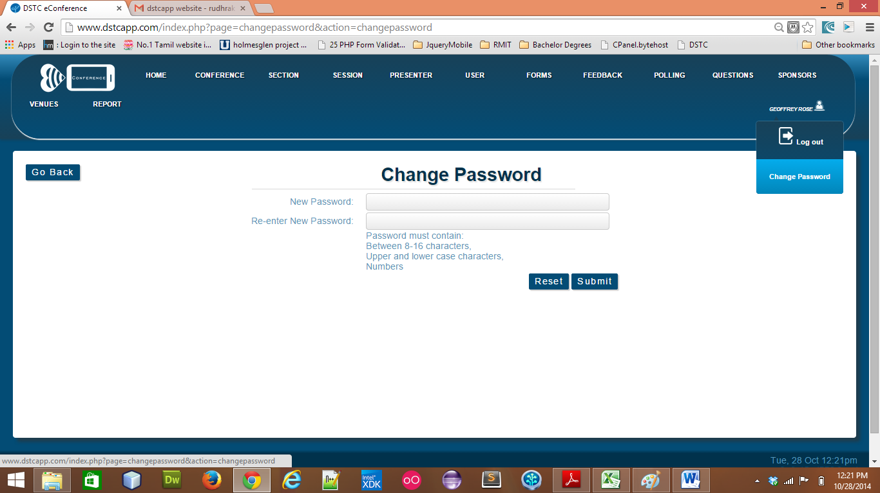

* User will be prompted to login to the system once they change their password.

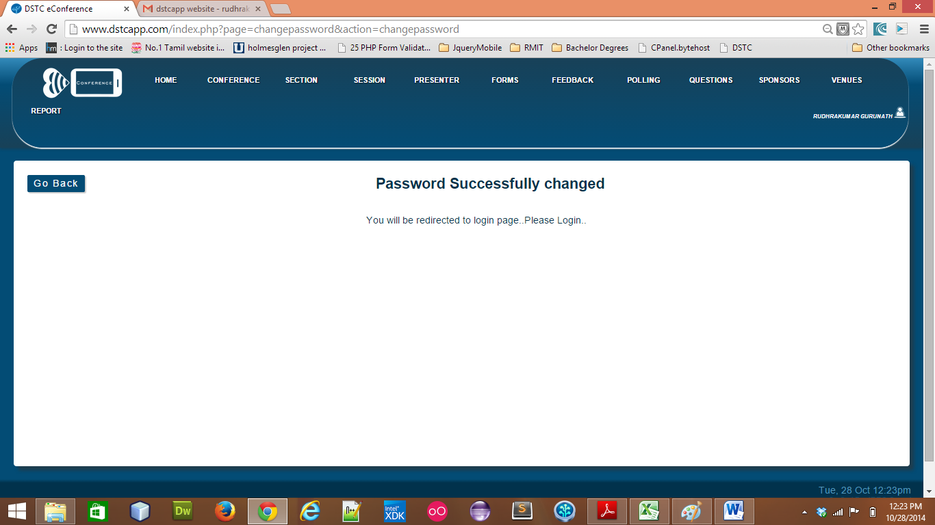

* Enter new password to log in.

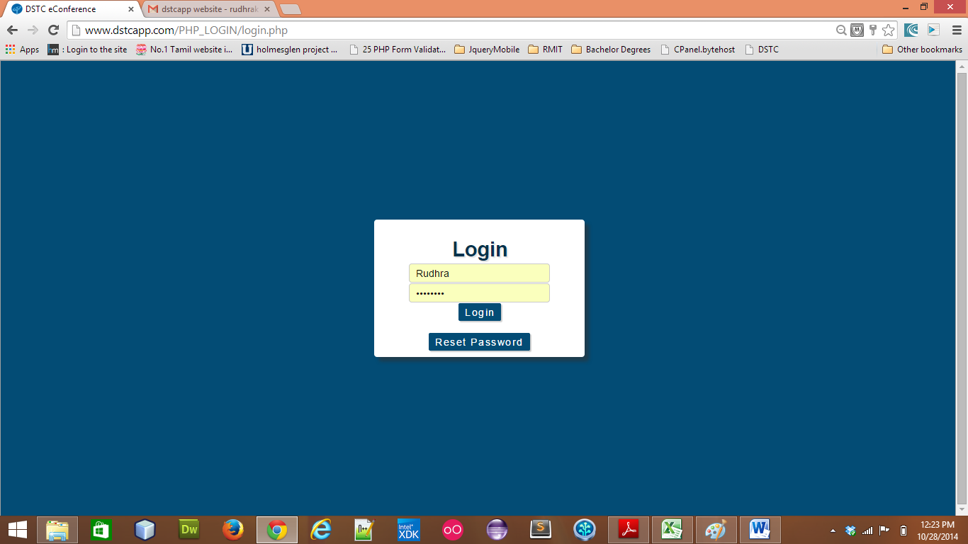

**Conference**

* Conference token is automatically assigned to the conference when created.

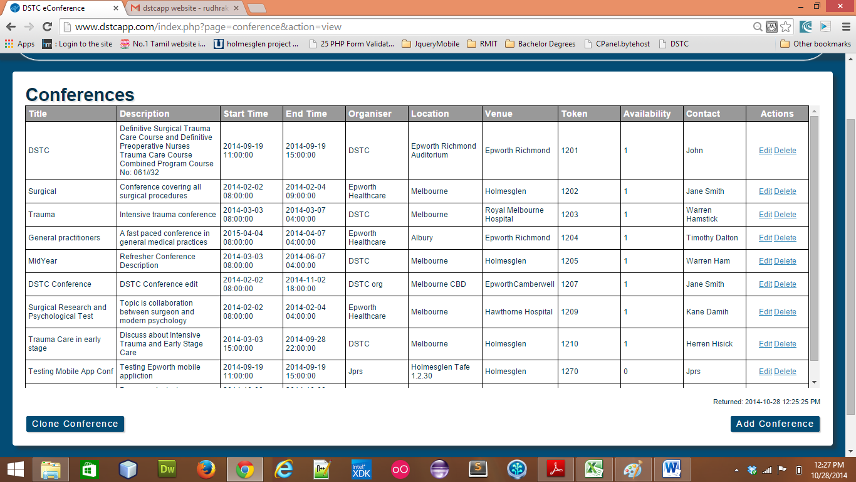

* To enable or disable the conference to be accessed by the mobile application use the availability dropdown menu in the web application and set to “On” or “Off”.

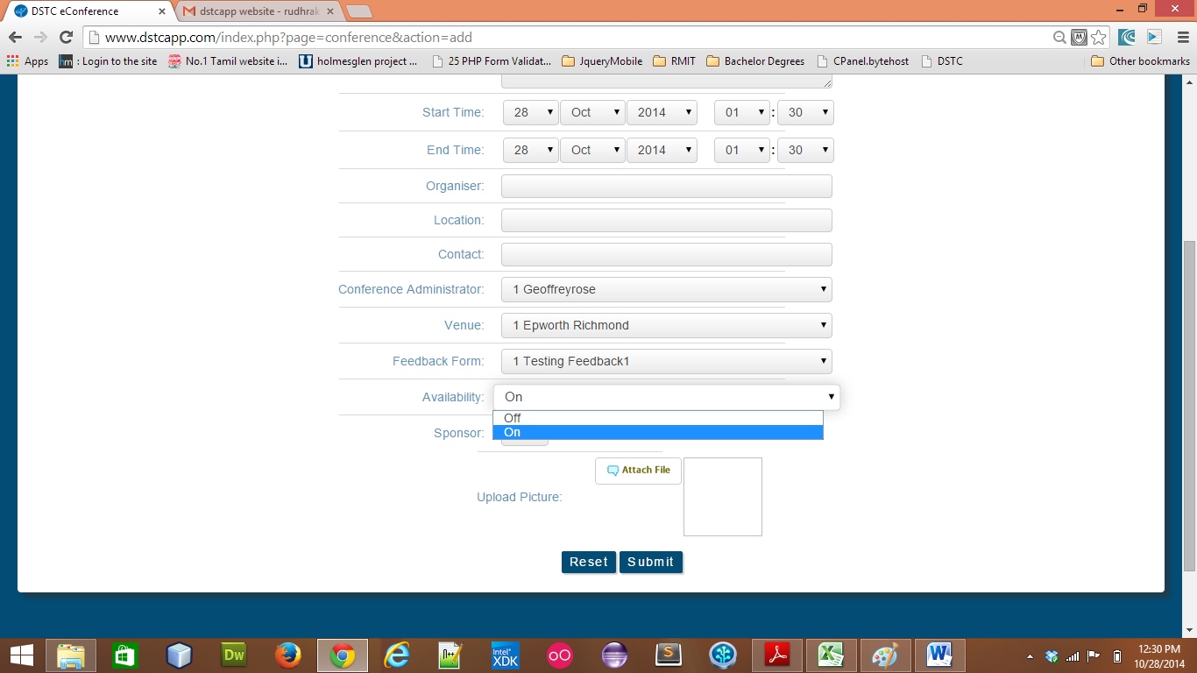

This can also be updated to “On” or “Off” when user, edit the conference.